1st verify that the data exists at this location in the Gdrive.

My Drive/SEIS_764_Group_Project/BigCat/RawData/test

My Drive/SEIS_764_Group_Project/BigCat/RawData/train

My Drive/SEIS_764_Group_Project/BigCat/RawData/val

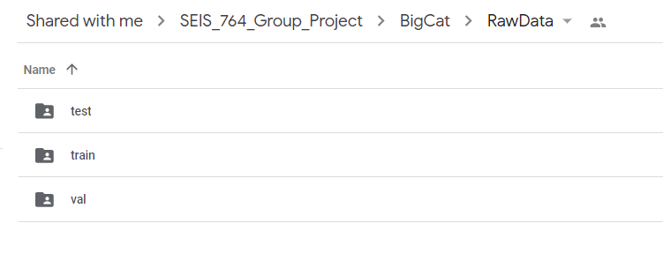

2nd go to this location to see and run all the colab notebooks

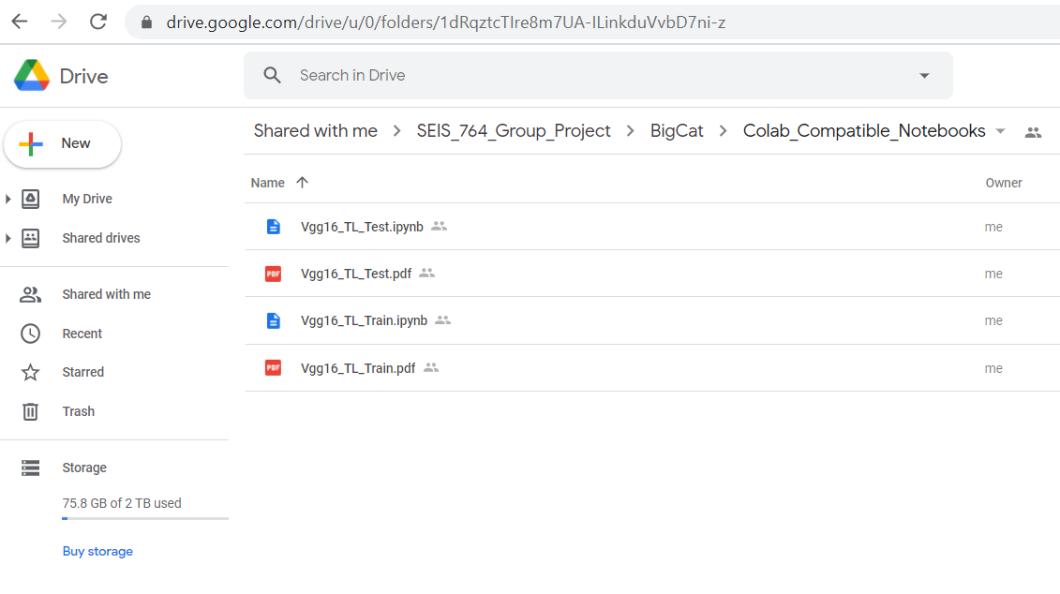

Click to run any one of these Colab notebooks

Pdfs are provided to see the working notebooks quickly

3rd here are the instructions to running one of colab notebooks

3.1 We right click on “VGG16_TL_Test.ipynb” and select open with and then click on Google Colaboratory

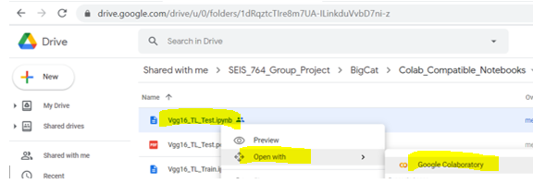

3.2 Within the Colab Notebook we verify that the data file path is correct

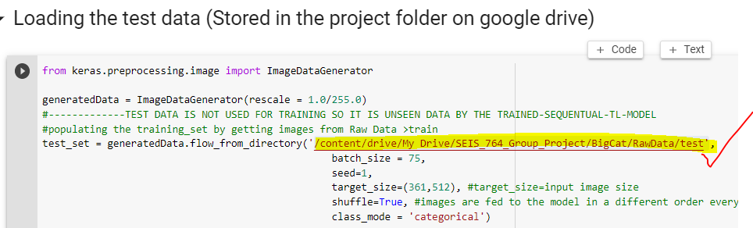

3.3 We click on Runtime > Run All in order to run the notebook

